Red Lake China Clay Works:
The Tramway and Clay Pipeline – An Exploration
By Steve Grigg
The previous two articles on the Red Lake China Clay Works have focussed on the clay extraction at Red Lake and the initial pre-processing of the clay at Greenhill Micas. This third article relates to the Tramway and Clay pipeline which extend from Cantrell, just outside Ivybridge, through to these two aforementioned locations. The map shows the tramway and pipeline, snaking their way around the hills and tors of southern Dartmoor, which for a good proportion of the route are adjacent to each other. There is a cross over point of the two constructions near Quickbeam Hill.

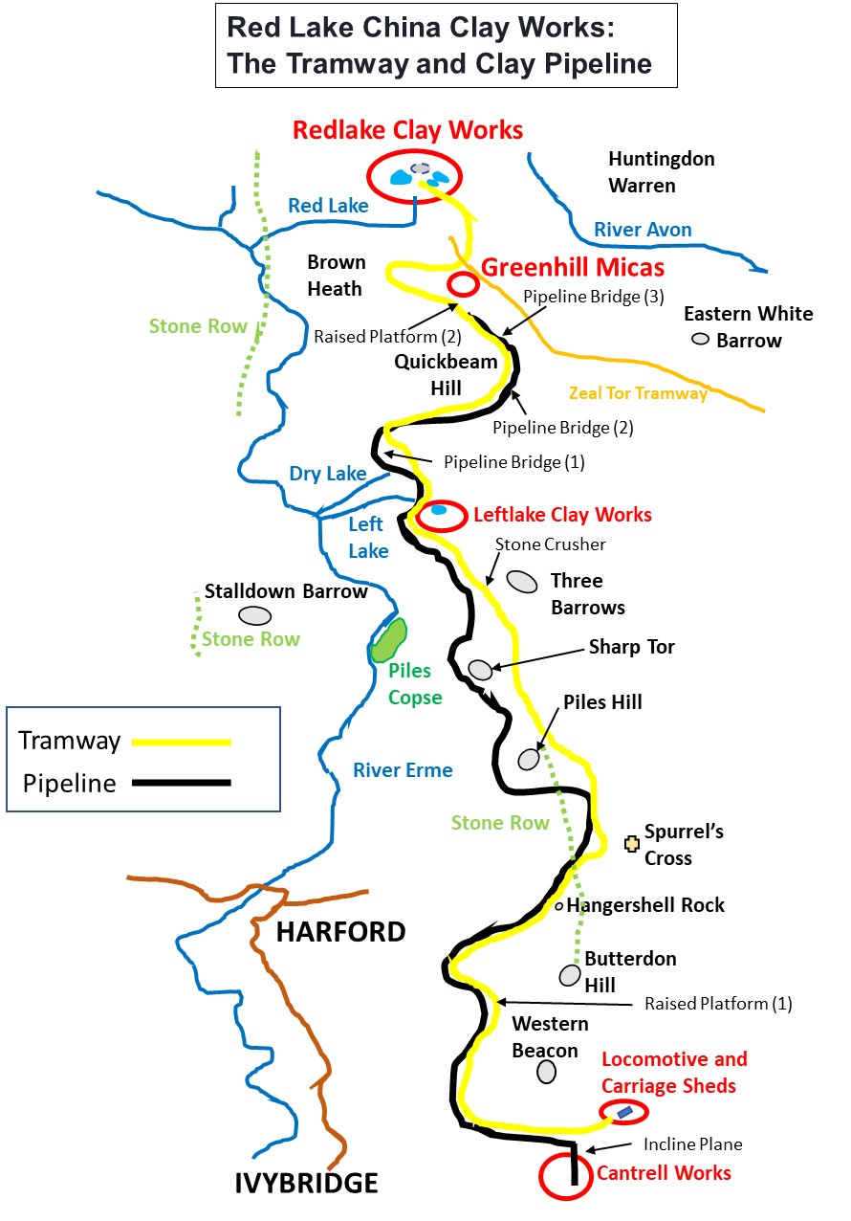

In writing this article, once again, due reference is made to the excellent E.A. Wade publications from 1982 and 2004 (The Redlake Tramway & China Clay Works) and to the assistance of Colin Yelland, who had provided E.A. Wade (“Ted”) with much of the material for his publications.

The Tramway:

The tramway was first surveyed in 1909 by R. Hansford-Worth to ascertain the feasibility of connecting Red Lake to transport links and hence the outside world. There had been around 4 years opposition to the venture as one might imagine including legal action. The protests included a Dartmoor Preservation Association protest in 1910. The construction of the tramway started in the latter half of 1910 with a gang of around 30 men. Initially, a temporary 2ft gauge track was laid, whilst the track bed itself was prepared. The final gauge of the line was 3ft. The sleepers were made of English oak and the rails were “fixed down” with bolts, clips and dog spikes. Ballast was provided by means of a quarry below Western Beacon, with a supplementary stone crusher at Three Barrows. For the record, 550 tonnes of rail were used alongside 16,000 oak sleepers.
The tramway construction was rapid, thanks to the course selected and it was officially opened on 11th September 1911 (albeit not 100% of the track had at that time been laid). It was finally completed in November 1911.
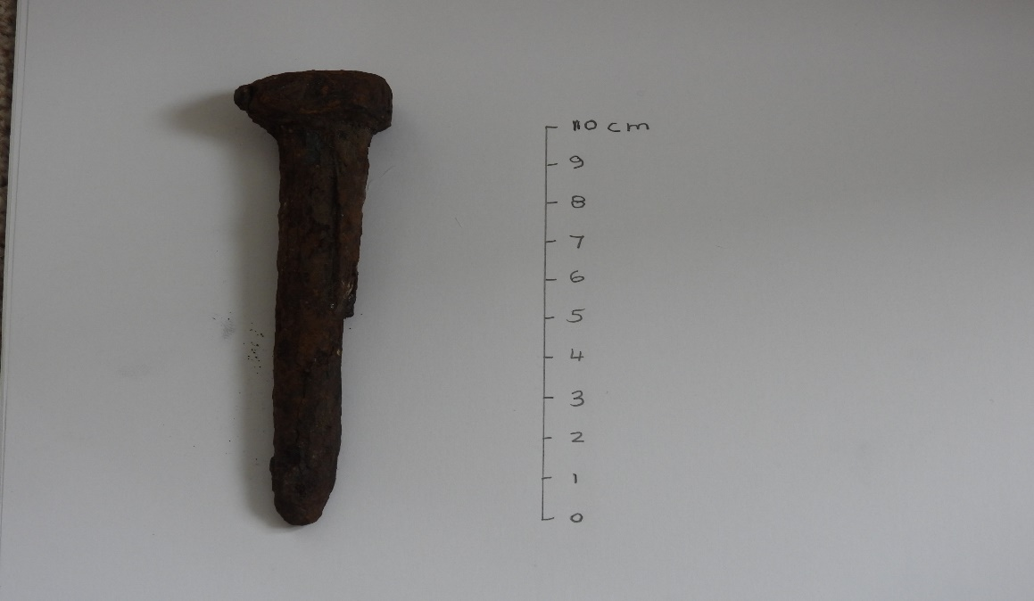

Rail to sleeper fixing, which looks like a possible dog spike. It is just over 10cm (4in) long

The tramway up to Red Lake starts near the top of an incline plane which would be served as a means of getting materials up and down the slope from Cantrell to the location below Western Beacon. That said, the distances quoted in this article are from a starting point of the locomotive shed, which was constructed approx. ¼ mile to the East. The infrastructure around the top of the incline plane and that at Cantrell (the final clay processing), will be covered in the final (5th) article in this series. The tramway, at various times had three locomotives, which were called Dartmoor, C.A. Hansen and Lady Mallaby Deeley (the latter two being named after the owner or the wife of the owner of the clay company in ownership of the operation at that time).
As we leave the incline plane the tramway route first proceeds in a westerly direction before going north. At 1 mile 25 chains (NOTE: there are 80 chains in one mile) from the locomotive shed, the line enters a shallow cutting. Here the modern Two Moors Way leaves the tramway and there is a 3ft high, 71ft long dry-stone platform (Raised Platform (1) on map). There is conjecture that its construction was to serve houses in the Erme Valley, a ½ mile to the west. However, a possibly more feasible explanation is that this construction (which realistically is not necessary) was down to the surveyor (Hansford Worth) who might have insisted on this to protect the Addicombe huts immediately to the west. The author believes this attention to detail becomes more evident when one considers the pipeline passes the other side of the huts. The tramway passes Hangershell Rock (at 2 miles 25 chains), Spurrells Cross (at 2 miles 63 chains) and Three Barrows (at 4 miles 44 chains). It is unfortunate that the line passes right through the long stone row between Butterdon Hill and Piles Hill. Below Three Barrows there is a siding and the remains of a stone crusher, which would have been used to produce ballast.
At Leftlake, the tramway crosses over a brick-built bridge (at 5 miles 17 chains). It is at this point the clay extraction including mica drags and ruined buildings can be found. A passing loop was put in at Leftlake.
Near to Greenhill micas, adjacent to the tramway, there is a second low stone-built platform (Raised Platform (2) on the map). This platform was built to serve the micas and is recorded as being 108 feet long and 2 foot, 8 inches high. The platform is at 6 miles 70 chains. Shortly after the platform the line passes its highest point (1490 feet above sea level). The line curves around nearly 360 degrees near Brown Heath. It then passes Red Lake Cottage, crosses the old Zeal Tor Tramway (7 miles 57 chains) before entering a final cutting, which is the deepest on the line. This section of the tramway can be flooded especially during the winter months. Leaving the cutting the final straight to Red Lake is reached and the clay extraction point. The total length of the line is 8 miles 17 chains (or just over 13km).
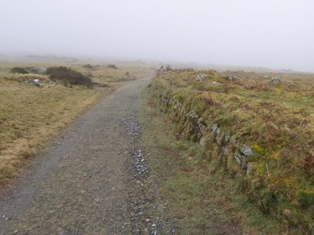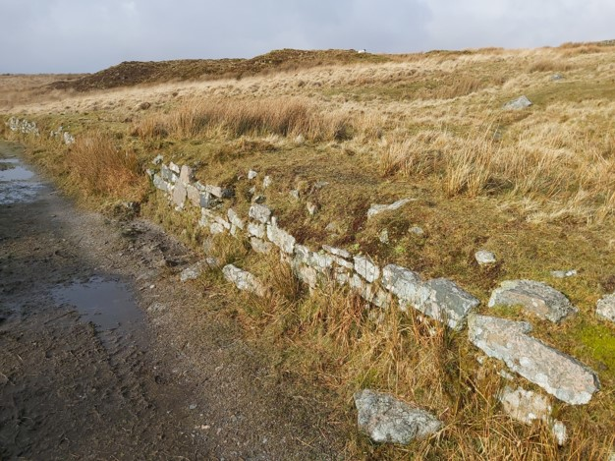
Raised platform (2) at Greenhill Micas.
Raised platform (1) on tramway, 1 mile 25 chains

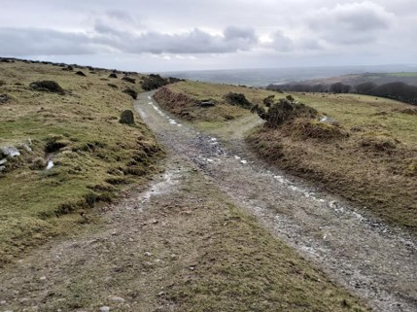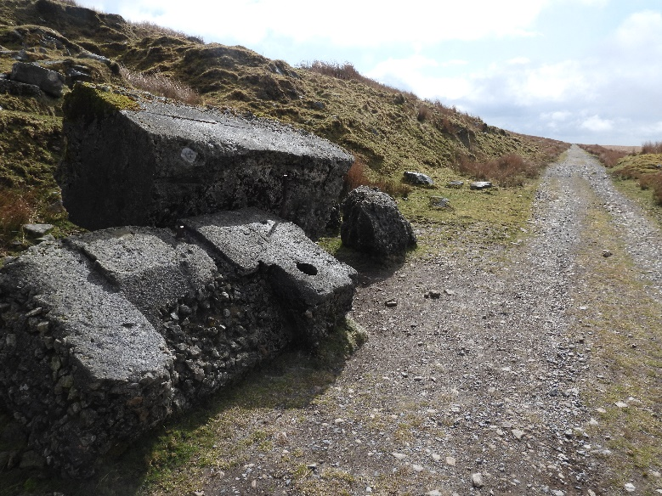
Stone crusher for ballast below Three Barrows
Two Moors Way turn off point from tramway

The Pipeline:

As discussed in a previous article in this series, the location of the Greenhill Micas complex is higher than the clay operation at Redlake. The author believes that this “hill” would have presented both a problem and ultimately the solution to the clay men in their desire to create a "gravity" fed pipeline to Cantrell some 8 miles away. Although not documented as such, it is theorised that the hill was chosen as the pre-processing complex rather than a location closer to Redlake. It not only provides natural contours for the process (ie dispensing filtered clay from one process to the next) but also the obvious place to start their “gravity” fed pipeline as from this point it is all downhill to Cantrell. The clay would have had the consistency of cream and was fed into a twin stoneware pipe system, relying solely on the 1000 ft height drop to Cantrell.
The pipeline today can be followed all the way from Greenhill Micas to the top of the incline plane above Cantrell. Along its route would have been 80 inspection points (only 76 are extant today with numbers 77-80 being cleared beside the incline plane). The pipeline was for much of its length buried just below the surface but three concrete bridges and some platforms were required at various points along its route due to the nature of the terrain. When the pipeline was first completed around late 1913, it was discovered that for approx. one third its length, it had water ingress and thus joints had to be dug up and had to be re-worked. This caused months of delay and ultimately Handsford-Worth his job (as he had supervised the pipeline contract).
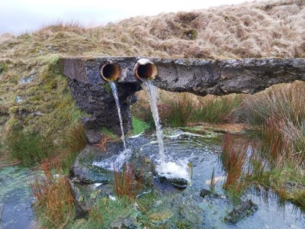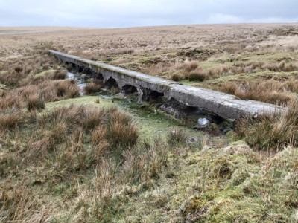
Concrete bridge (2) with 10 arches at SX65101 64510.
Concrete bridge (3) at 6 miles and 65 chains.

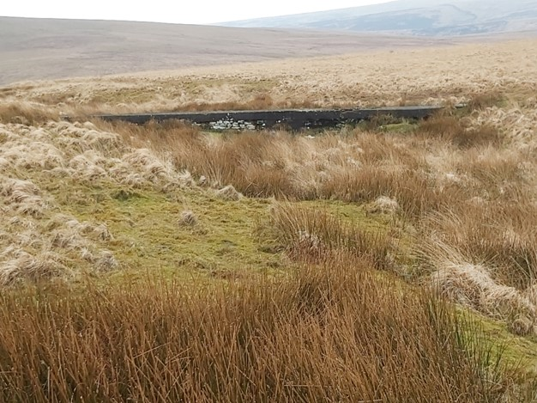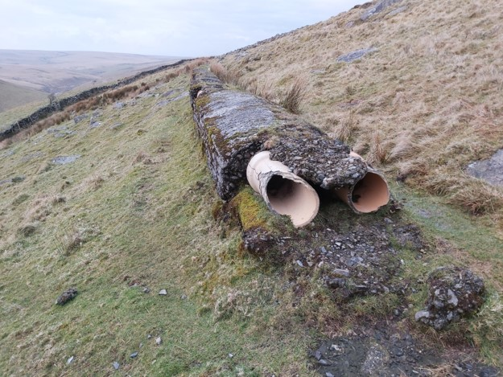
Pipeline concrete encasement at Sharp Tor
Concrete bridge (1) at 5 miles 45 chains.

The stoneware pipeline was washed out with water for 15 minutes before clay was fed into it. Apparently, the clay sometimes froze and was unable to be washed out. At Leftlake, the pipeline disappears underground near the brick-built bridge and the author suspects that it is an integral part of that construction. At Leftlake (from 1922), the clay from that operation entered the pipeline. The two sources of clay were never mixed as that at Leftlake was considered inferior quality. The point where the Leftlake clay was added appear to be at the 22nd Inspection point from Greenhill. It is unfortunate that the pipeline is on the opposite side to the tramway from the Leftlake micas, so one assumes a temporary pipe laid across the track when the clay feed was being used.
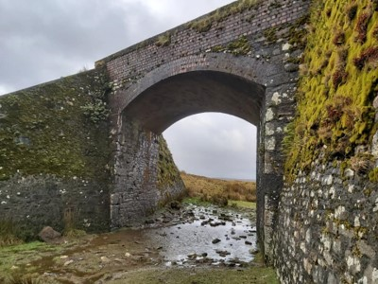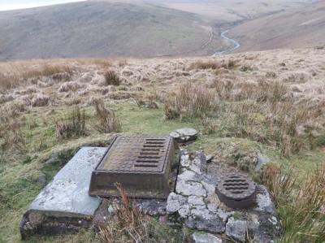
Inspection point 30, high above the Erme
Leftlake Bridge

At Cantrell the clay flowed into open settling tanks and more water was drained off before it was finally pan-kilned.
The Red Lake China Clay works series of articles will be continued and the clay extractions at Leftlake, which were (re)opened in 1922 are the subject of the 4th part in this series of articles and will feature in the next publication.
The details and information in these articles cover just a fraction of the fascinating industrial venture from the early 20th century and the author thoroughly recommends those thirsting for more refer to the Wade publications.

