Red Lake China Clay Works:
Leftlake Clay Extraction – An Exploration
By Steve Grigg
The previous three articles on the Red Lake China Clay Works have focussed on the clay extraction at Red Lake, initial pre-processing of that clay at Greenhill Micas and the tramway / pipeline between Red Lake and Cantrell. In this, the fourth article the clay extraction at Leftlake is covered, which interestingly pre-date those at Red Lake but were considered as a commercial proposition as they were re-opened during the Red Lake clay extraction era. The Leftlake clay workings were active over two periods, namely; 1850-1858 and 1922-1932.

In writing this article, once again, due reference is made to the excellent E.A. Wade publications from 1982 and 2004 (The Redlake Tramway & China Clay Works) and to the assistance of Colin Yelland, who had provided E.A. Wade (“Ted”) with much of the material for his publications.

The earliest known references to a china clay pit on the moor dates from 1502 and refers to one at Hook Lake, which is a small tributary of the Erme and can be found a short distance from both Leftlake and Red Lake. Fast forward 200 years and Devon clay in the 18th century was considered by William Cookworthy to be inferior to the Cornish counterpart as it had an inferior colour when fired, so consequentially the Devon deposits weren’t exploited until much later. However, the first serious survey of the Devon clay didn’t come until 1827, when pit owners from St. Austell (John Dickens and John Warrick) came to Dartmoor. Dickens and Warrick obtained leases in 1830 for extraction in the Lee Moor and Shaugh Moor areas.

Around 1850, two employees of the Shaugh Moor / Lee Moor works, John Bray and John Stephens discovered clay deposits at Leftlake and set up a rival pit. Bray and Stephens exploits at Leftlake lasted until 1858 and failed for three main reasons: Firstly, the “kaolinisation” was poor with only 10% of the raw material washed being china clay; secondly, they had huge problems with the drying of the clay, which is recorded could take up to 9 months; Thirdly, transportation of the dried clay would have posed a huge logistical problem. The Blackwood Path passes through the workings and it is probable that horse drawn wagons of the 1850’s used this track to Wrangaton.

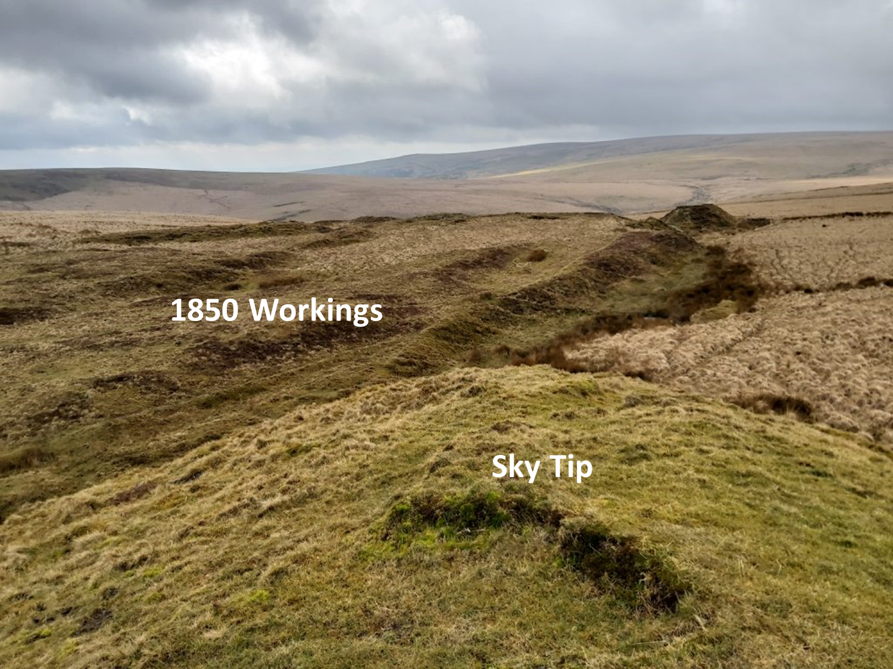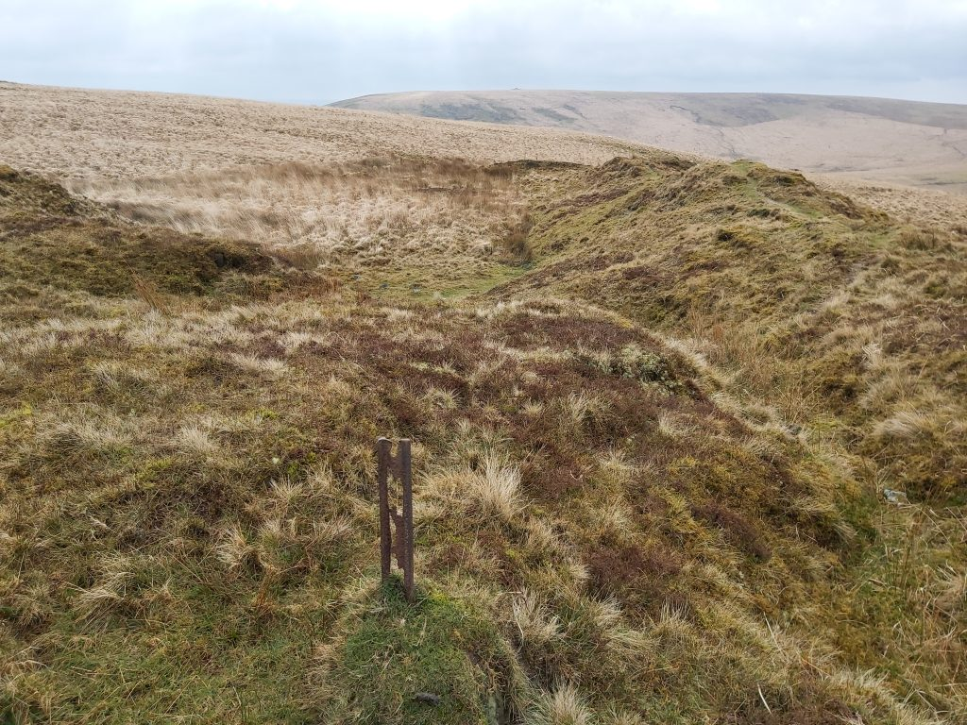
The photographs above are a view from the sky tip looking towards 1850s workings with the Erme valley beyond and an old rail, amongst these early workings and is presumably from the 2oth century tramway

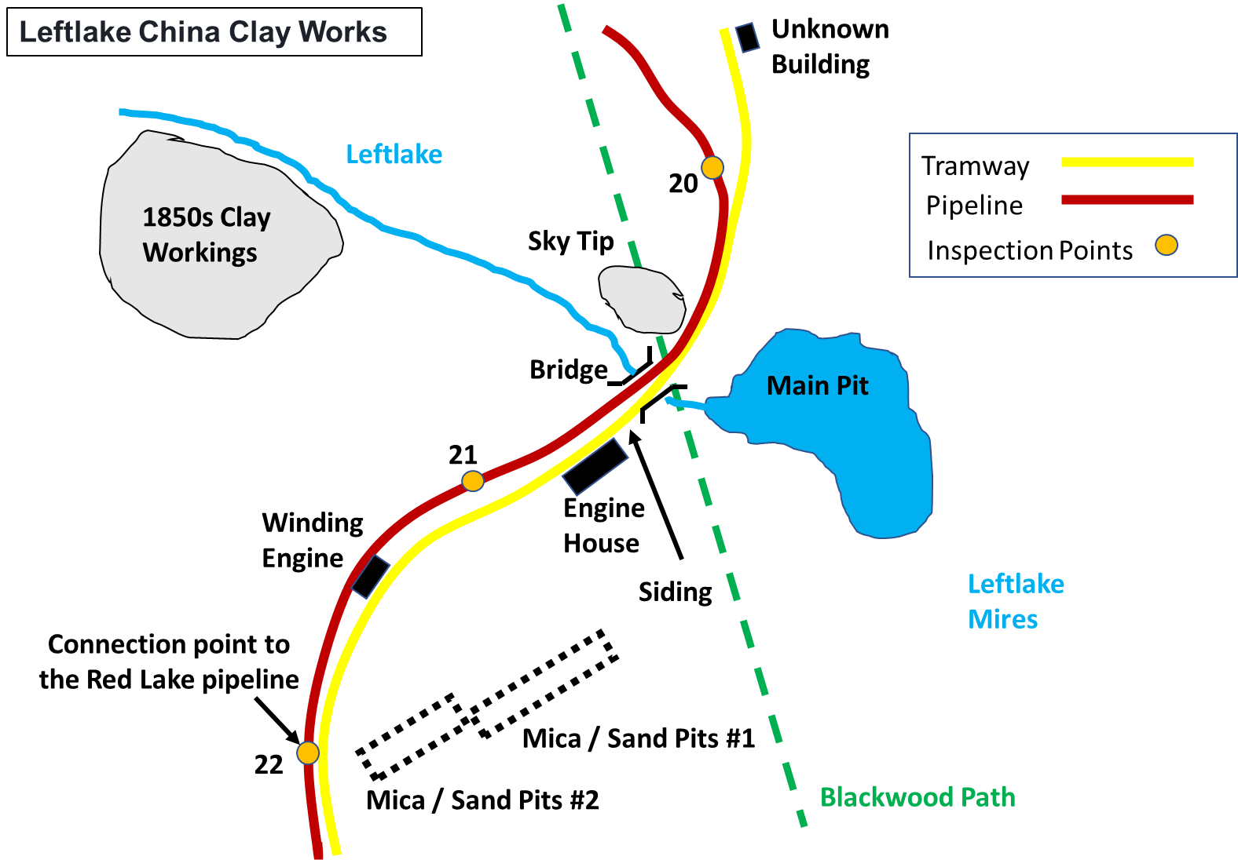

In 1922, Sir Harry Mallaby Deeley the principal shareholder of the Red Lake operations, under the name of Ivybridge China Clay Company Limited purchased the lease for the Leftlake workings in order to increase the overall output. As the Red Lake tramway and pipeline already passed through the old 1850s workings, the additional infrastructure required was minimal.
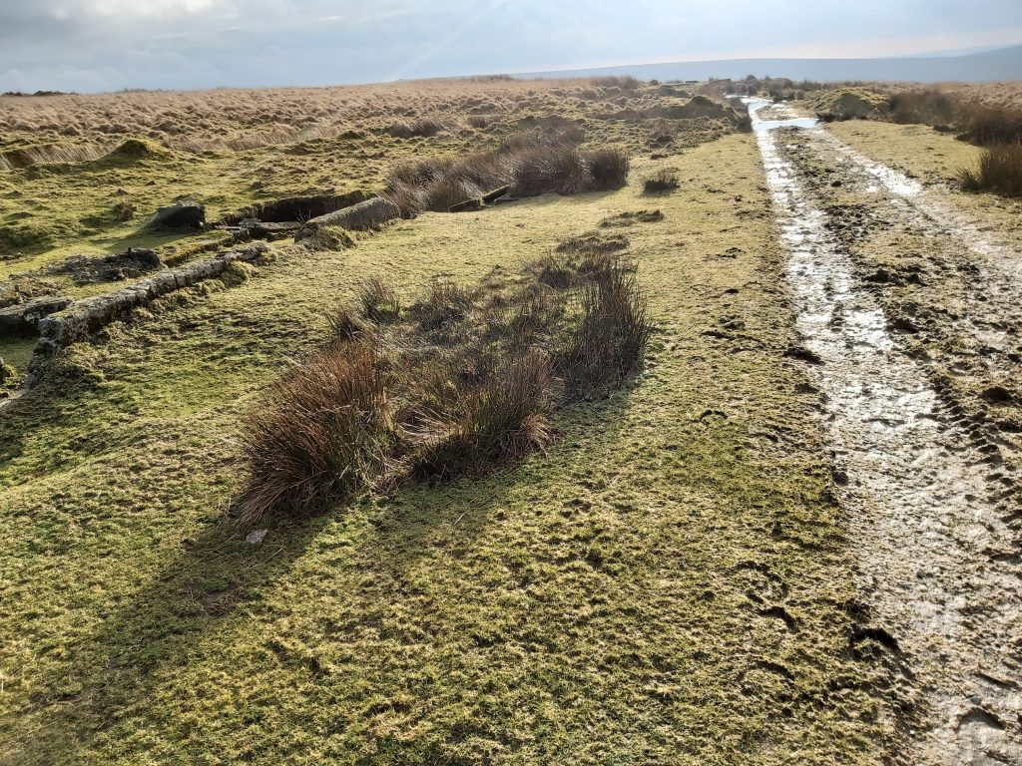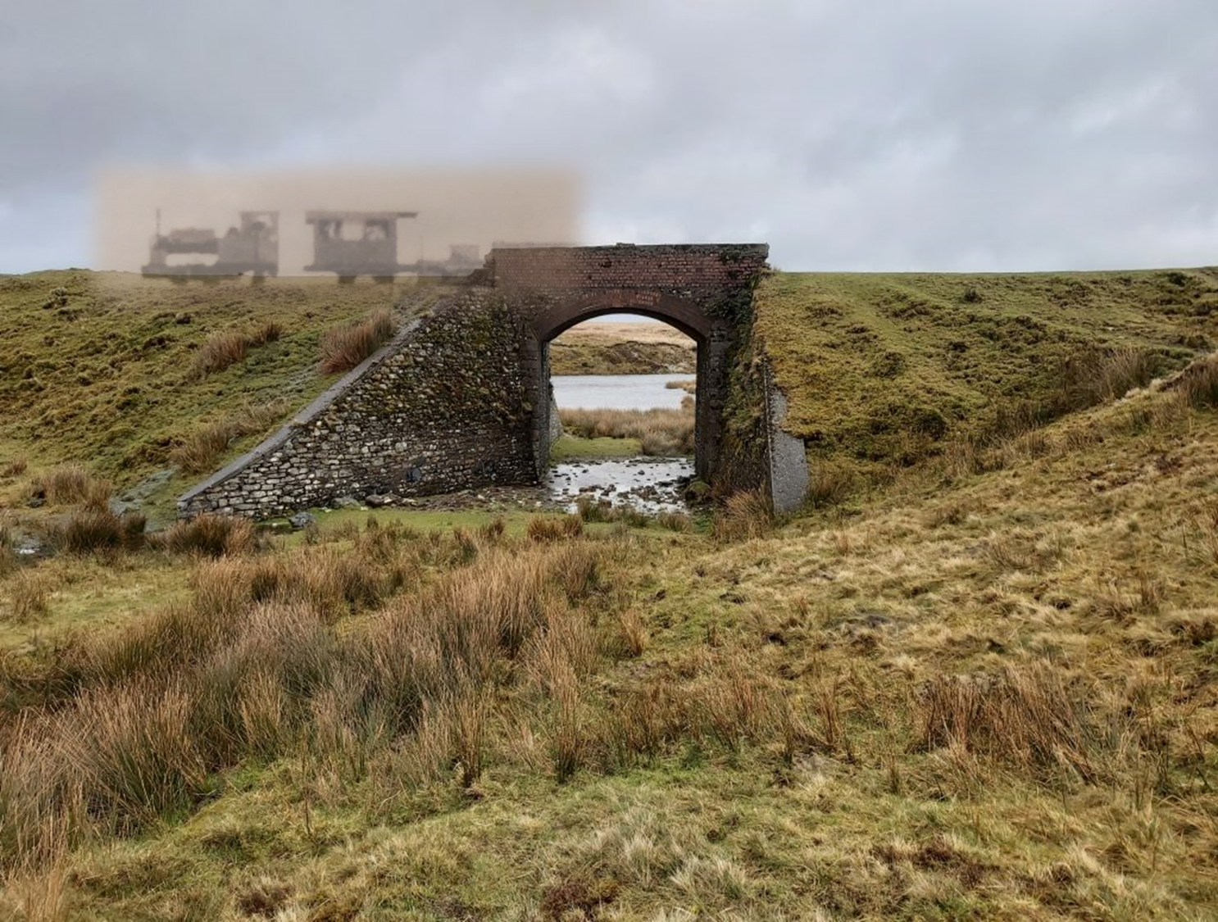
A passing loop / siding was constructed in 1922 and in the picture next to it is the Engine house. This is just south of the bridge. The bridge at Leftlake is 5 miles and 17 chains from the start of the Red Lake tramway (locomotive shed).

The ghostly “overlay” onto the 21st century picture is that of engine “Dartmoor” with carriage number 3 and a flat wagon, probably taken pre-1922 before the works were restarted. The pit can be made out beyond the bridge. The bridge, would have been built around 1911. On inspecting the course of the Red Lake clay pipeline, it looks probable the pipeline was built into the structure of the bridge.

For the 1922 re-opening of the clay operations at Leftlake, two (Hornsby) pumping engines had to be installed into an engine house. One of the engines was used to pump water from the pit and the second was used to pump clay slurry up to the two newly constructed sand and mica drags. After the (pre) processing of the clay (similar but not as extensive as that at Greenhill Mica’s), it was passed into the Red Lake clay pipeline. As the Leftlake clay was inferior to the Red Lake clay, it was sent down the pipeline to Cantrell at a different time to the Red Lake clay.

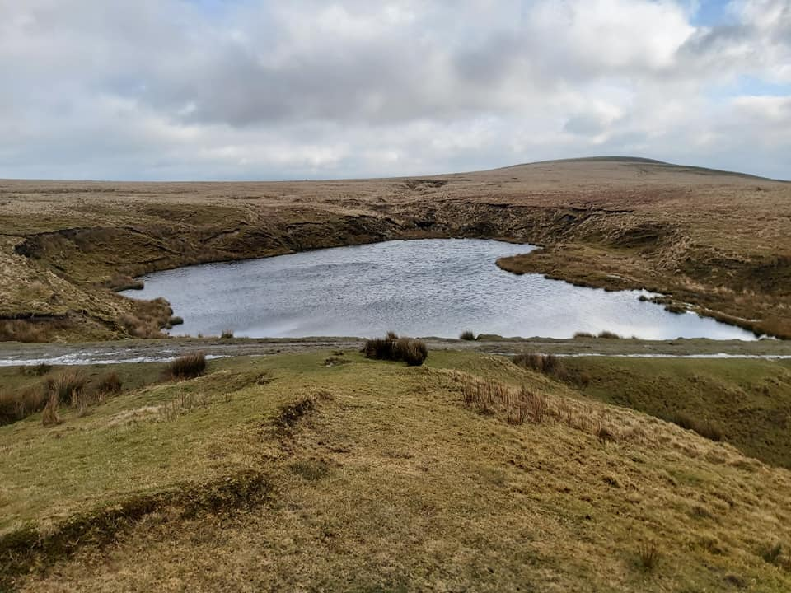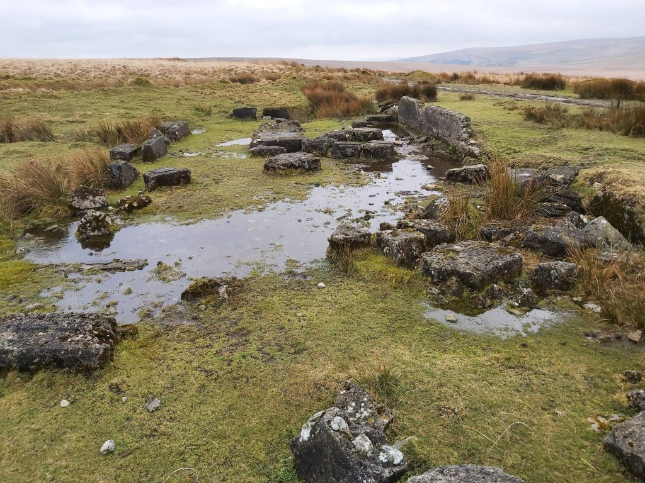
Left: View of the clay pit at Leftlake taken from the sky tip with Three Barrows on the horizon. Right: Foundations of the engine house.

The engine house structure was timber framed and clad with timber or galvanized sheeting resting on a concrete base wall. It can be found at SX64627 63408. A worker was tasked to walk to Leftlake every Sunday in order to tend the pumps ahead of the start of the working week. The two engines here also produced electricity for the site. If one explores the foundations of the engine house a reed lined rectangular pit 2.5m x 0.6m can be found and is believed could have housed a fly wheel from a horizontal engine.

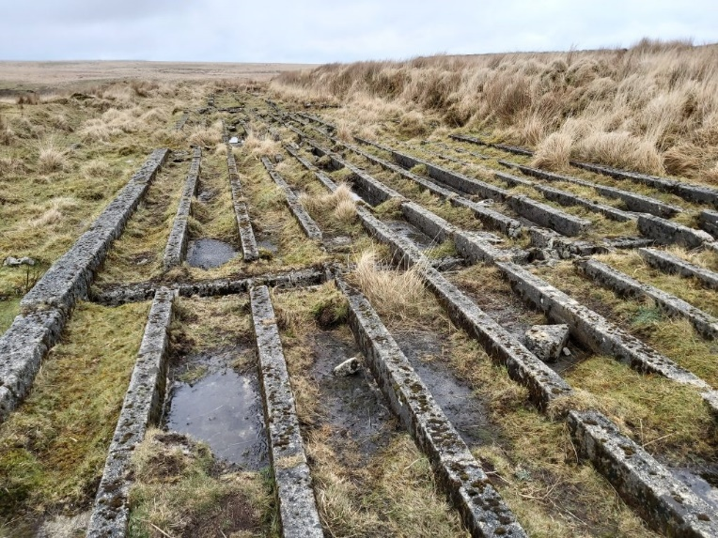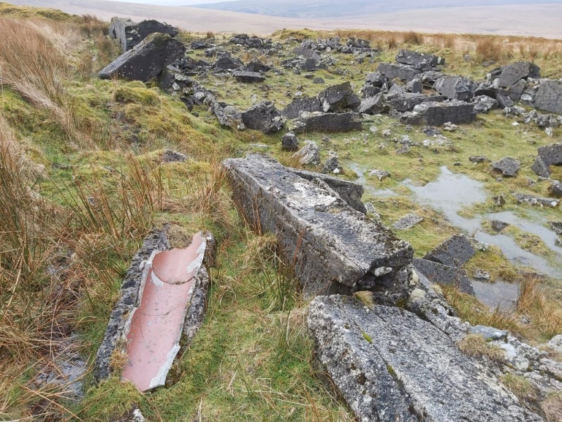
Concrete sand and mica drags, first section. Concrete sand and mica drags, second section.

The clay deposits at Leftlake proved to be less extensive than first predicted. Interestingly, the 1922 operation concentrated to the east of the tramway, whereas the 1850s operation had concentrated on the west side. The belief is that the deposits were more extensive on the west side. There isn’t a definitive date that the author can find regarding how long the Leftlake extractions were operative, but estimates range from 2 years to 10 years when the whole Red Lake operation closed (circa 1932) when the company collapsed.

After the clay (pre) processing it was passed into the pipeline for its gravity fed journey to Cantrell. Surveying the area, the most obvious point where the clay was put into the pipeline appears to be at the 22nd Inspection point from Greenhill Mica’s. If so, it was unfortunate that the pipeline is on the opposite side to the tramway from the Leftlake micas, so one assumes either a temporary pipe laid across the track when the clay feed was being used or a feeder pipe is laid beneath the tramway. The stoneware pipeline was washed out with water for 15 minutes before clay was fed into it and the two sources of clay (Red Lake and Leftlake) were never mixed as that at Leftlake was considered to be of inferior quality. At Cantrell the clay flowed into open settling tanks and more water was drained off before it was finally pan-kilned.
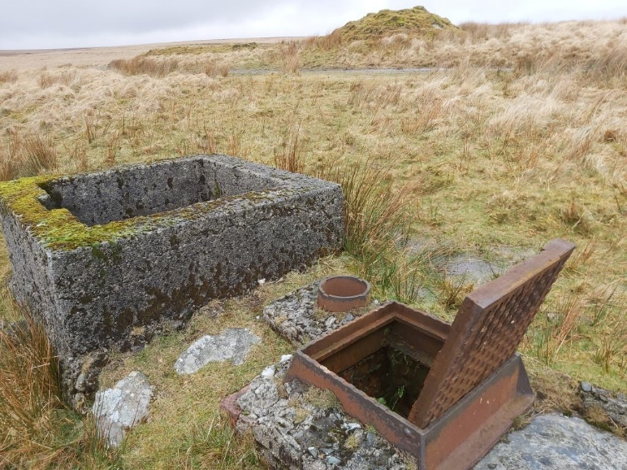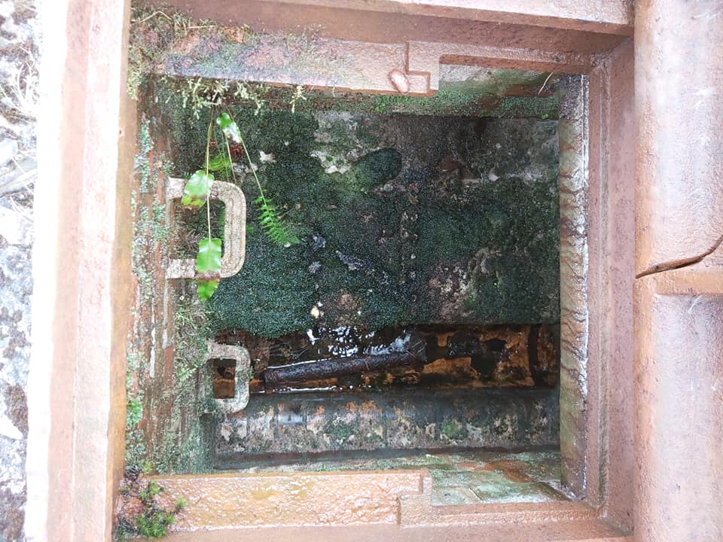
The square concrete structure is believed by the author to have been the most likely location where the Leftlake processed clay entered the Red Lake pipeline. Next to it is an iron inspection point and circular vent being one of 80 built down the length of the pipeline. The concrete sand and mica drags, (second section) is across the tramway behind the mound.
The foundations of a Winding Engine house are also still evident at Leftlake to the west of the tramway. Wade states: “This once housed the Winding Engine from which a wire rope passed, via a pulley, over the spoil (sky) tip connected to the wagon or wagons on the incline which passed over the tramway into the pit.” The author has also observed the foundations of a small building just to the north of the workings, its purpose is unknown.
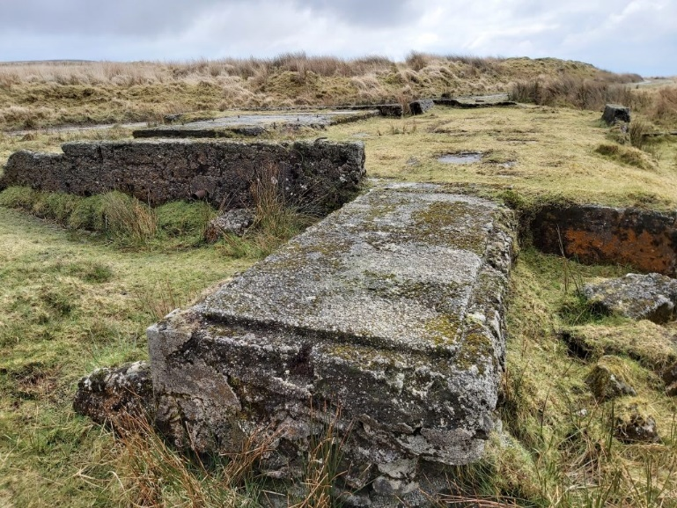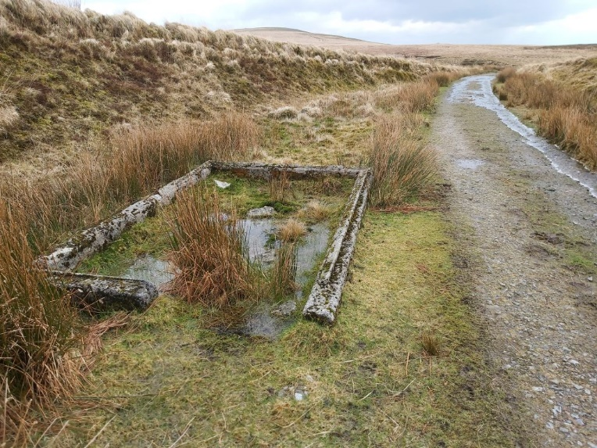
Winding Engine building foundations (left) can be found at SX64555 63371. The unknown square building / structure (right) next to tramway north of Leftlake workings can be found at SX64717 63599.
.
The Red Lake China Clay works series of articles will be concluded in the next publication, with the Cantrell clay processing plant for the Red Lake (and Leftlake) clay workings, the incline plane (which fed the main tramway), the start of the tramway with its locomotive / carriage sheds and the end of the clay pipeline.

