Red Lake China Clay Works:
Greenhill Micas – An Exploration
By Steve Grigg
In the last edition of the Dartmoor News, the author spoke of his lifelong love of Dartmoor, especially the industrial archaeology surrounding Redlake China Clay Works and its environs between Cantrell and Redlake itself. Having previously written about the clay extraction, this second article relates to the initial pre-processing of the clay at Greenhill Micas and briefly touches on Quickbeam Quarry, the Explosives Magazine and Red Lake Cottage in the same area, all of which form part of the rich history of the Red Lake China Clay Works.

Reference once again is made to the excellent E.A. Wade publications from 1982 and 2004 (The Redlake Tramway & China Clay Works) and to the assistance of Colin Yelland, who had provided E.A. Wade (“Ted”) with much of the material for his publications.

The area around Greenhill Micas is surrounded by three well defined tracks / tramways, which provide relatively straight forward access to this part of remote southern Dartmoor: Abbots Way, Zeal Tor Tramway and the Red Lake Tramway itself. In spite of this, much of this first stage filtering process complex of the clay might easily be missed as it’s hidden from immediate view. For those interested in industrial archaeology, it is well worth "following the process" from north east to south west, starting near to Crossways (marked on OS Maps).

The location of the Greenhill Mica complex is at around 460m above sea level, whereas the clay operation at Redlake is at around 445m above sea level. Therefore the “hill” where the complex is would have presented both a problem (being 15m higher) and ultimately the solution to the clay men in their desire to create a "gravity" fed pipeline to Cantrell some 8 miles away. Although not documented as such, I would theorise that the hill was chosen as the pre-processing complex rather than a location closer to Redlake as it not only provides natural contours for the process (ie dispensing filtered clay from one process to the next) but also the obvious place to start their “gravity” fed pipeline as from this point it is all downhill to Cantrell.
Using a plan in the Wade publications and the OS Map, I have created a plan of the Greenhill Mica complex and its environs (which appears below). Following a discussion with Colin Yelland, we noted that Wade got a lot of his information from a 1920 auction catalogue of the site. In fact, the map on page 52 of the first edition of his book is almost an exact copy of the auction catalogue plan. That said, there is one small amendment from the original (Wade) plan insofar as the Explosives Magazine has been incorrectly located. It is actually to the south of the Abbots Way, whereas Ted located it to the north. The plan in this article corrects this.

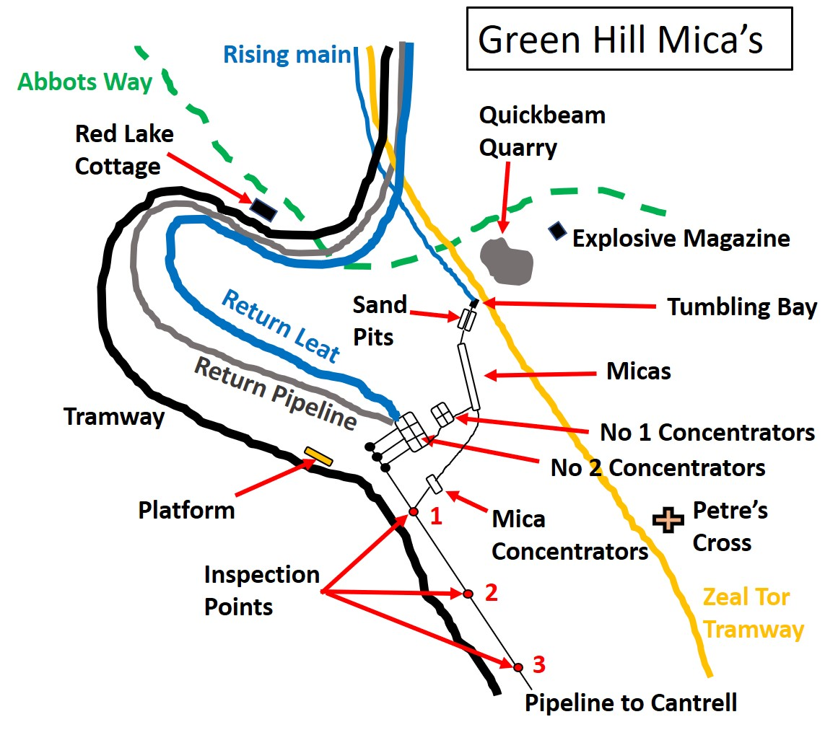
Let’s start the exploration………The Explosives Magazine, which is located at grid reference SX65176 65915, is a conspicuous structure close to the Abbots Way. Keeping explosives away from the extraction and pre-processing operations is an obvious safety consideration.
The Explosives Magazine is designed to allow fresh air to circulate into the structure. The roof was designed to be the weak point in case of explosion to divert or guide the blast upward as opposed to just outward. Should there be an accidental explosion, the roof would have been the sacrificial point protecting anyone who may have been in the locale at the time. Explosives were used to blast any un-kaolinised granite that existed in the pit which was in the way of china clay extraction.
Not far from the Explosives Magazine is Quickbeam Quarry (SX65059 65826), which most likely provided material for construction in the area. It is marked (but not labelled) on OS maps. Interestingly there is a small platform located between the Explosives Magazine and Quickbeam Quarry, which is not mentioned in the Wade books and which the author surmises, was used to load material from the quarry onto horse-drawn waggons.

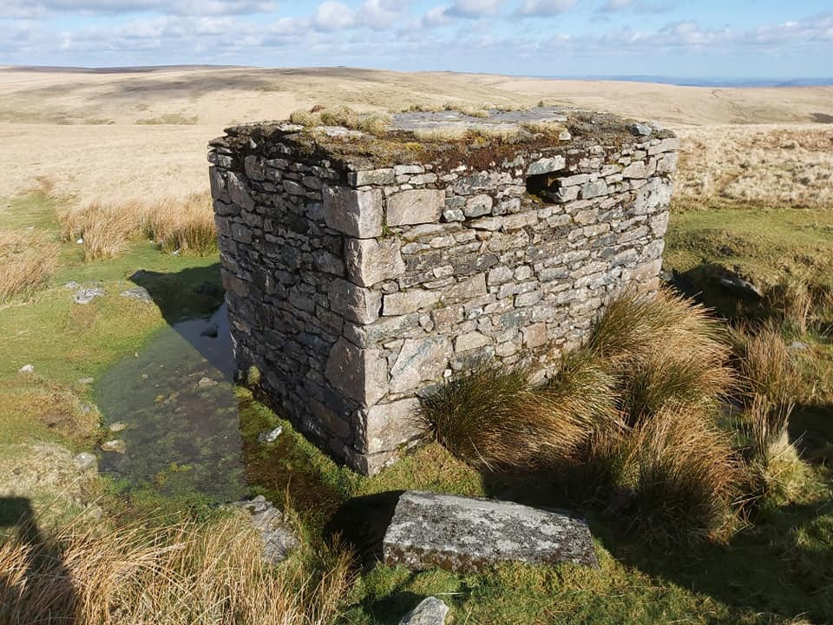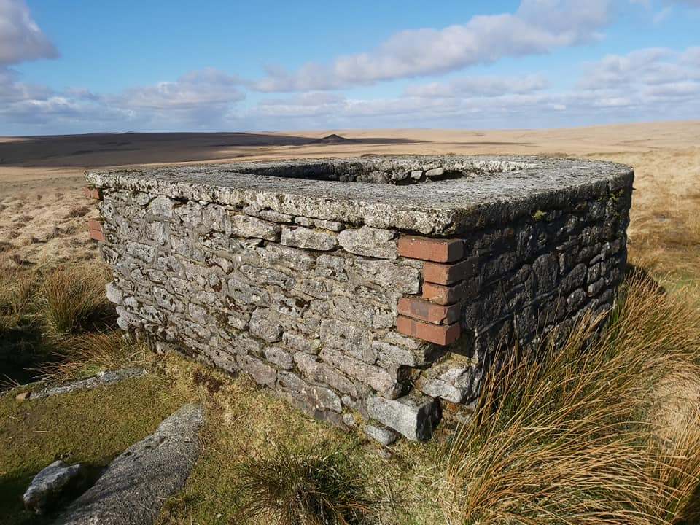
Tumbling Bay, the start of extraction process
The Explosives Magazine, looking East towards Avon Valley and Heap of Sinners.

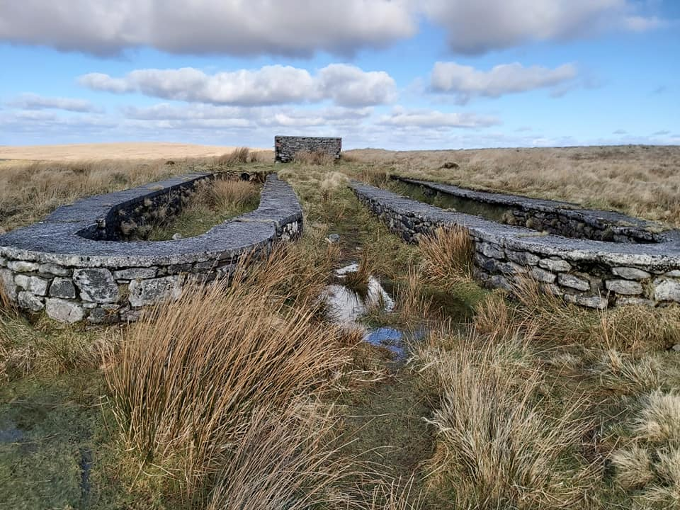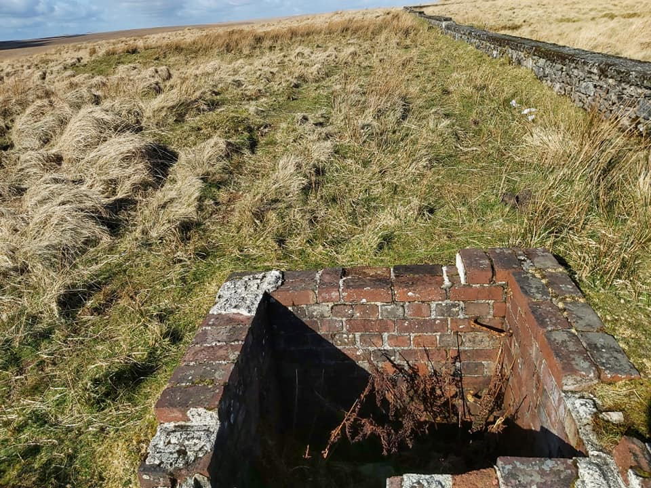
One of a number of inspection holes next to the micas. This one at SX65023 65667
The Sand Pits with the Tumbling Bay in the centre / top of the picture. SX65044 65746

The start of the Greenhill Micas pre-processing of clay was at the Tumbling Bay, where the liquid clay was pumped via a 15 inch (38cm) steel rising main. It is located at grid reference SX65047 65759. It is an obvious structure, which to anyone who has walked the Zeal Tor Tramway, would have passed by. From the Tumbling Bay, liquid clay was separated into two sand pits, the first stage in separating light sand. Next the liquid, was transferred into the micas, which are 335 feet (102 m) long by 43 feet (13 m) wide.
After the micas, there are two huge constructions named Concentrators 1 and 2. The Concentrators were settling pits and there is still evidence of some “agitation” having been part of the process here. The first area of concentrators (1) comprises four sections, each 38 feet (11.5m) square by 13 feet (4m) deep. Each section seemed to have evidence of a concrete floor sloping inwards to the centre. The second section of concentrators (2) have sections 52 feet (16m) square by 12 feet, 6 inches (3.8m) deep. These are very impressive constructions and do not reveal themselves to the explorer until the last moment. There are many cast iron sluice gates and valves here as well as dozens of bricks scattered around. There are three types of bricks to be found GWR, CANDY and Hexter Humpherson. There also appears to have been a final stage of mica concentrators, which as shown in the plan, were fed by both the micas and the Concentrators no.2.
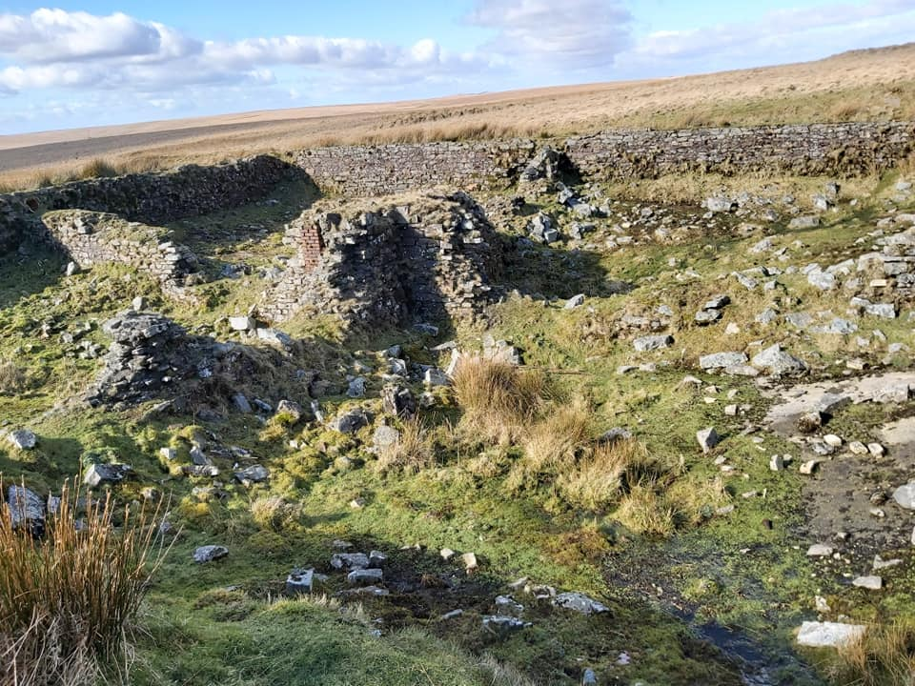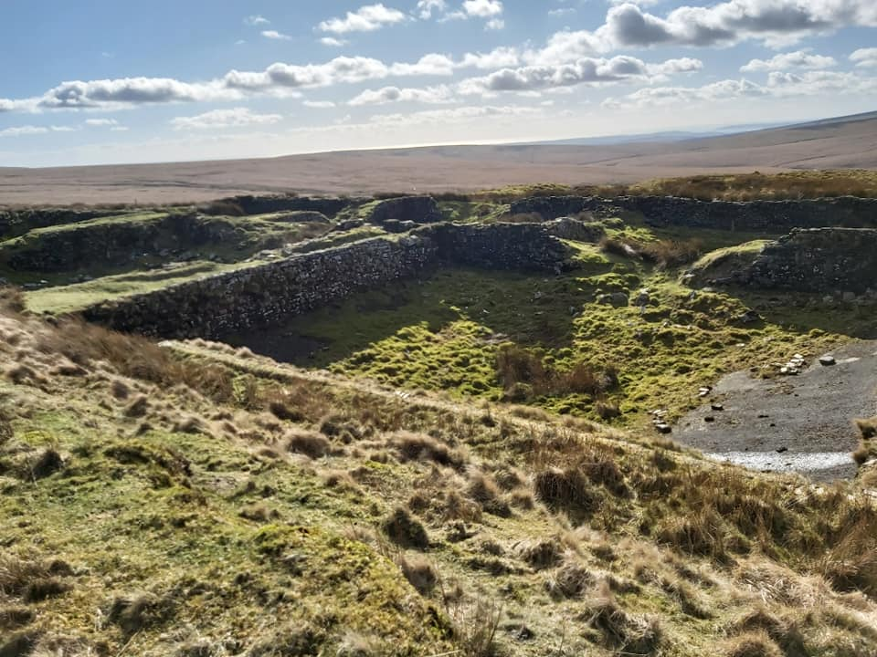
Concentrators 2 complex. The Erme valley can be seen in the distance
Concentrators 1 complex. Four huge square brick, stone and concrete bays.

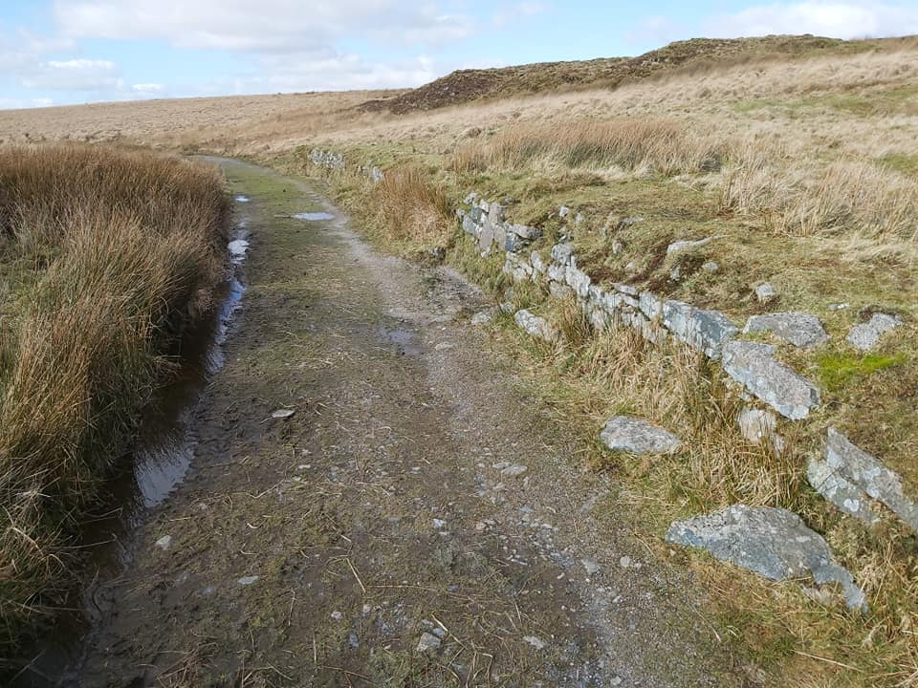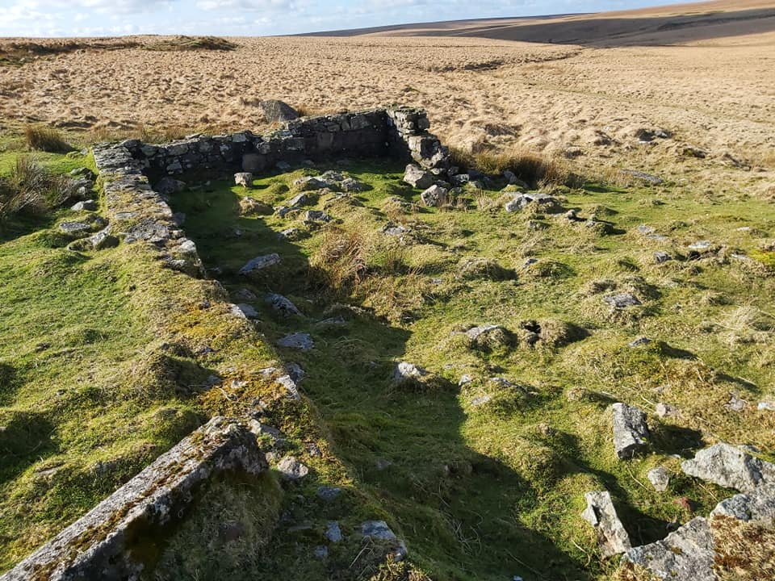
Stone platform located at 6 miles, 70 chains from the locomotive shed at Western Beacon. SX64884 65503. Wade states that.
Red Lake Cottage, at SX64720 65941 with view to Red Lake Sky tip.
. SX64884 65503. Wade states that.

After all this pre-processing the liquid was gravity fed, down to Cantrell for the post-processing of the clay. The story of the pipeline and the tramway and its construction to Cantrell will be the next article in this series. Before we leave the area, there are a few other points of interest to note. Firstly, with careful exploration, the start of a return leat back to Red Lake can be found. This was to recycle water which was a precious commodity needed to operate the "monitors", which were used to extract the clay in the clay pit. Next, adjacent to the tramway, there is a low stone-built platform. This platform was built to serve Greenhill micas and is 108 feet long (33m) and 2 foot, 8 inches (0.75m) high. Finally, next to the tramway back towards Redlake, the foundations of Red Lake Cottage can be found. This was the home of Captain and Mrs Bray (who ran the hostel at the main Redlake complex).

