Red Lake China Clay Works:
Final Clay Processing at Cantrell and the Tramway infrastructure below Western Beacon – An Exploration.
By Steve Grigg
The previous four articles on the Red Lake China Clay Works have covered the clay extraction at Red Lake, initial pre-processing of that clay at Greenhill Micas, the tramway / pipeline between Red Lake and Cantrell and the clay extraction at Leftlake

To complete the pentalogy, this fifth article covers the final clay processing operation at Cantrell and the infrastructure at the start of the tramway below Western Beacon.

In writing this article, once again, due reference must be made to the excellent E.A. Wade publications from 1982 and 2004 (The Redlake Tramway & China Clay Works) and to the assistance of Colin Yelland, who had provided E.A. Wade (“Ted”) with much of the material for his publications.

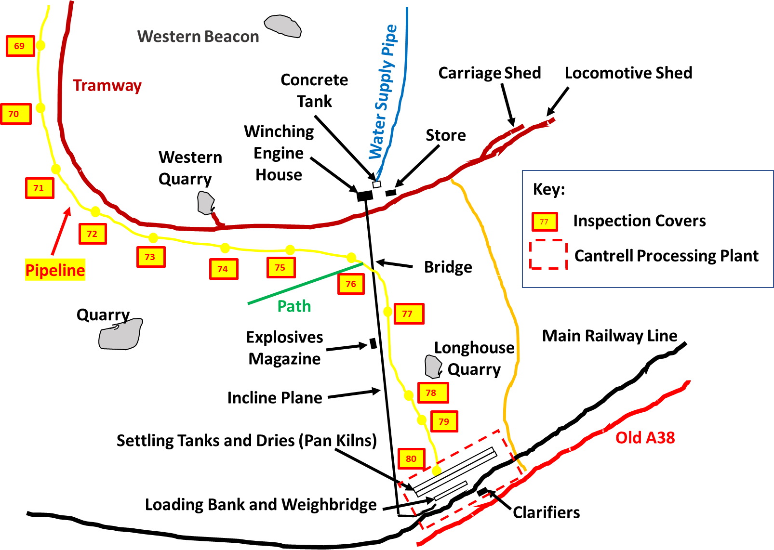

The sketch map shows the key points of interest covered in this article with the exception of the incline plane as it is located on private farmland.

After the clay (pre) processing at Green Hill Mica’s and at Leftlake (in later years), as previously mentioned, the clay was passed into the stoneware pipeline for its gravity fed journey to Cantrell.
The stoneware pipeline was washed out with water for 15 minutes before clay was fed into it and the two sources of clay (Red Lake and Leftlake) were never mixed as that at Leftlake was considered to be inferior quality. As Cantrell is approached, the pipeline runs very close to the tramway as it curves around Western Beacon. Although the pipeline is buried, its course can easily be followed by locating the inspection points along its route and then looking for obvious ground disturbance.
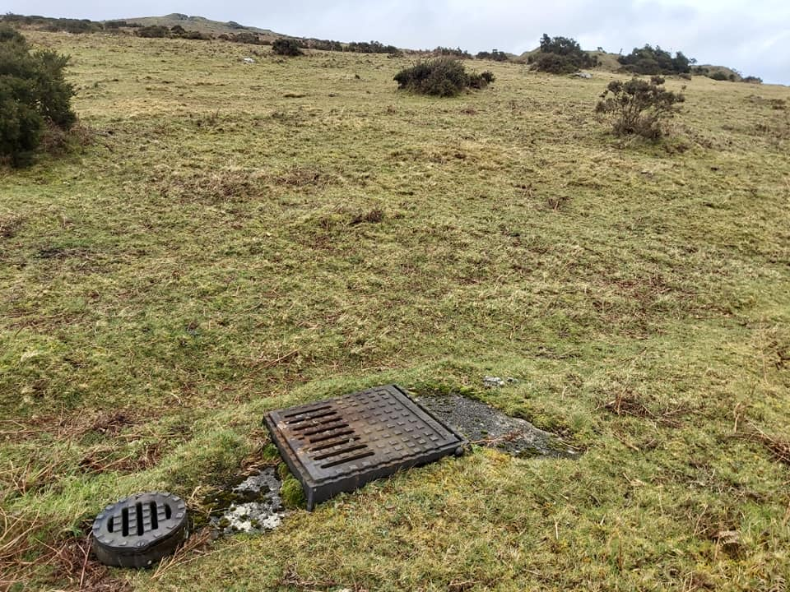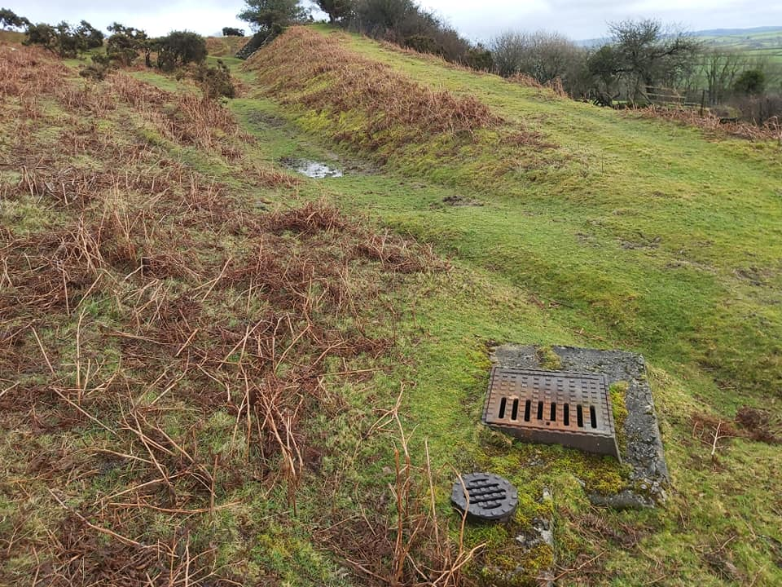
Inspection point 76 at SX65580 57043. This is the one nearest the incline plane and is believed to be the last one as 77-80 are recorded as no longer existing.
Inspection point 73 at SX65132 57102. Western Beacon can be seen on the horizon and the line of the tramway follows the gorse near the top of the picture.

At Cantrell the clay from the pipeline flowed into 12 settling tanks where water was drained off before it was finally pan-kilned, bagged and dispatched.
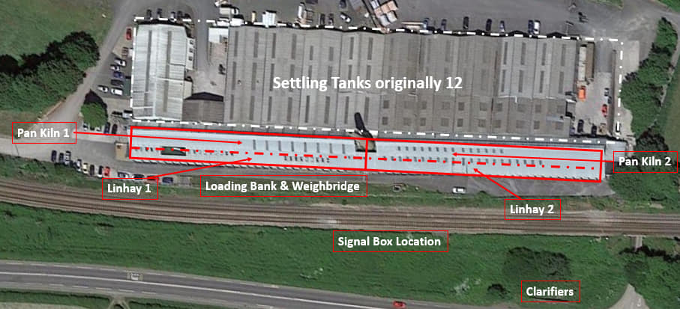
This aerial view shows the 12 settling tanks, which fed two pan kiln dries (coal fired hence the 100′ chimney). The clay was, in turn then hand shovelled into the two linhays for bagging. The bagged clay was then placed onto the loading bank and taken away by rail.

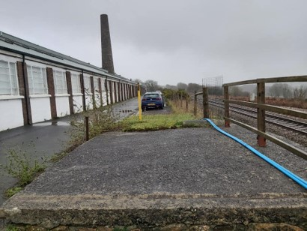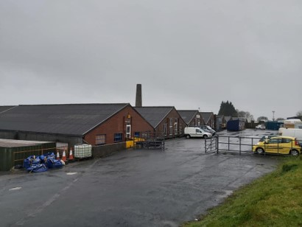
At the front of the Cantrell Processing Plant the chimney which was on top of a coal fired furnace used for the two pan kilns is still in place. The vertical brick columns were the outer part of two linhays.
At the back of the Cantrell Processing Plant the pitched rooves where 12 settling tanks were located can be seen. They are re-purposed today and now there are only 10 such roofs.

The settling tanks were each 114ft (35m) x 43ft (13m) x 8ft (2.5m) deep with stone paved floors and were capable of holding 10,000 tons of clay. The drying capacity of Cantrell was estimated as being 30,000 tons per year. Next to the settling tanks were two large pan kilns, each 268ft (82m) x 15ft (4.5m) with a central furnace and 100ft high chimney. Each of the pan kilns had a “travelling bridge” across it which was used to distribute the clay evenly. The clay took 1-2 days to dry before it was shovelled into two large linhays 287ft (87.5m) x 20ft (6m) where up to 4,000 tons of dried clay could be stored. The linhays had openings to the adjacent weighbridge (a Pooley’s weighbridge capable of weighing 30 tons) and a loading platform.
The picture of the front of the plant, clearly shows its location in relation to the railway line (main line between Plymouth and Newton Abbot), which made this an obvious mode of transport for the onward distribution of the refined clay. It is recorded that by having their own siding, the operation saved 2s. per ton compared with having to transport the clay by road to the nearest railway station. The loading platform can still be seen today as can the location of the original weighbridge. There would also have been a signal box (on the opposite side of the tracks) specifically for the Cantrell siding. The final excess waste from the process was placed into one final clarifier, which is still in place today next to the main road between Ivybridge and Bittaford (look out for the walling near to the junction to a narrow lane to the east of the plant). Any overspill water would have been released to the Lud Brook via a waste pipe to near Torpeek to the south.
Charles Cottier had obtained a lease for Red Lake from the Duchy of Cornwall in 1908 and in 1910 he set about forming a company to work the clay. At this time he purchased Cantrell farm (which comprised 64 acres) as part of the operation.
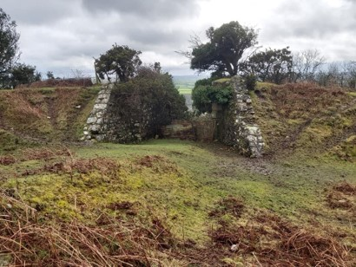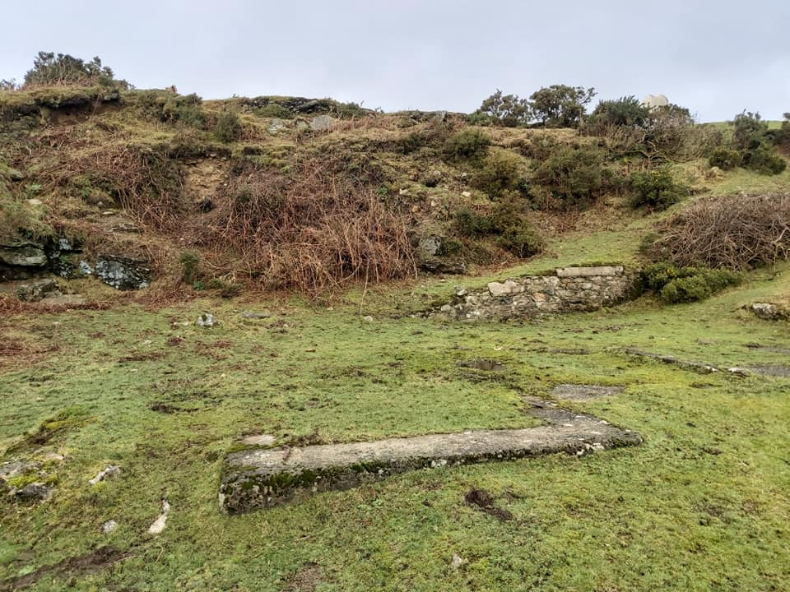
At the top of the incline plane was a winding engine house. The location of the Winding engine house foundations can be found at SX65629 57150
Top of the incline plane. Wagons were raised and lowered down to Cantrell here. It is also the place where the clay pipeline left the moor.

The “gap” where the incline plane reaches the open moor (as shown in the photograph) appears where there is an old track to a nearby quarry. The incline plane leads to a winding engine house, which was divided into three bays, namely; one for a 4ft 6in (1.4m) winding drum, one for a 12 hp steam engine and one for a bunker for coal. The engine provided the power to raise and lower wagons to the tramway from Cantrell below up and down the 1 in 5 incline. The cable was 2,210 ft long (the incline being 2,100 ft). Wagons (with materials for Red Lake) were raised and lowered twice per week on average.
Just above the winding engine house is a concrete water tank (at SX65639 57165). There is a lid on top which when struck with a walking pole suggests from the return echo back it is quite large. The tank was used as a reservoir for water brought to this location via a 1.5 in (4cm) pipe from Lud Brook to the northeast. Close by to the winding engine house and the water tank the foundations of the old store can be located (SX65664 57147). If one travels a few hundred metres to the west, the old Western Quarry can be found (SX65235 57141), which is where the ballast for the track and embankments came from. All distances on the tramway were measured from the locomotive shed and this quarry is 41 chains up the track (there are 80 chains to the mile).
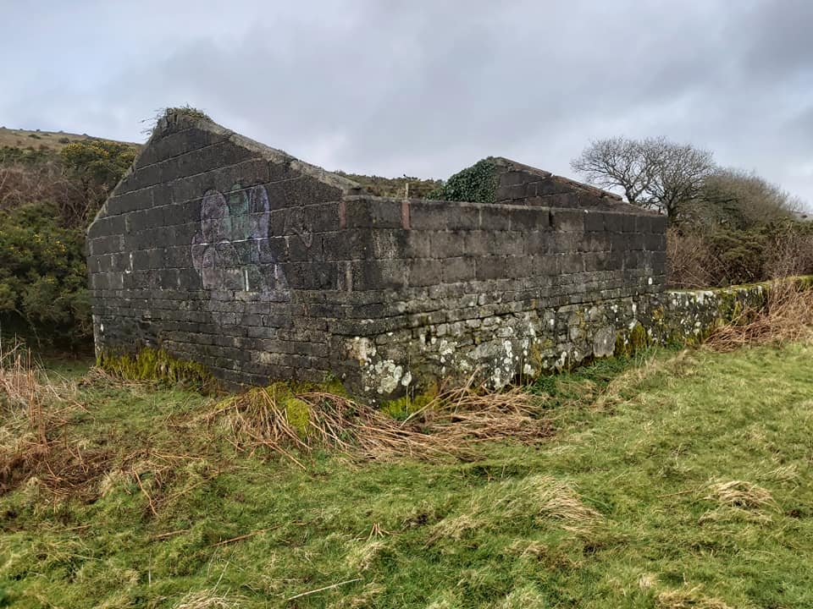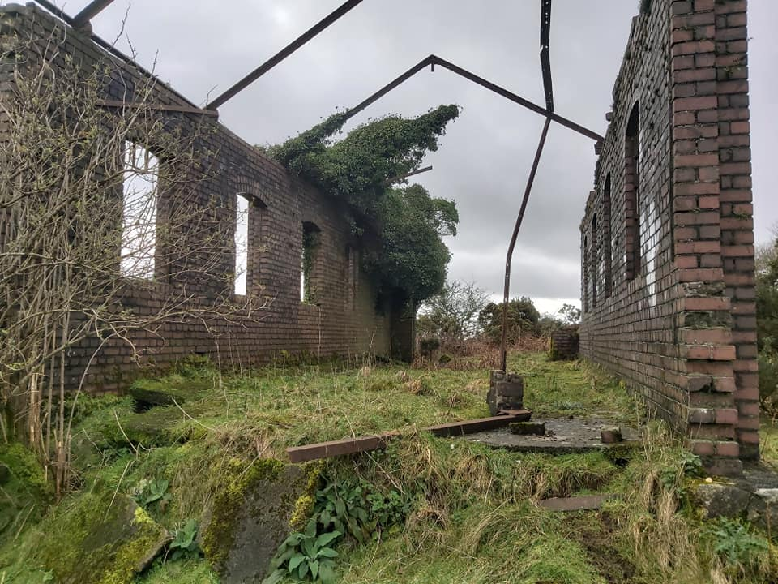
The carriage shed. SX65931 57301.
The locomotive shed at SX65990 57354.

To the east of the incline plane the ruins of the former locomotive and carriage sheds can be found. There were four locomotives which one time or another operated on the line (C.A Hanson, two “Dartmoor” and Lady Mallaby Deeley). All locomotives were kept at Cantrell overnight. The ruins of the locomotive shed show each side of the building had five windows. The roof would have been corrugated iron sheets. The tramway used three bogie passenger carriages capable of carrying up to 30 passengers. There is a carriage shed close to the locomotive shed and the low walls of the original building have been built upon by more “modern” light weight concrete blocks which were part of an addition to convert it into a pig sty.
The first “Dartmoor” locomotive was in fact 2ft gauge and was used in the latter stages of construction of the 3ft gauge tramway. She was dispatched from Kerr Stuart and Company (Stoke-on Trent) on 28th July 1911 and pressed into work during August that year transporting rails and sleepers over the temporary and ever diminishing 2ft gauge construction line. The tramway was officially opened on 11th September 1911. The first 3ft gauge locomotive was C.A Hanson (named after Charles Augustin Hanson, the principal director) and was dispatched on 13th September 1911, so effectively, although the tramway had been opened, the tramway didn’t have a locomotive for a number of days. C.A Hanson was scrapped around 1921.
The second 3ft gauge locomotive (third in total) was also named “Dartmoor” and had been dispatched from its supplier on 27th January 1912. The “Dartmoor” construction (2ft gauge) locomotive was part exchanged for the second “Dartmoor” (3ft gauge) locomotive. It seems that C.A. Hanson locomotive did the bulk of the operational work up to the time of it being scrapped. An interesting part of the second “Dartmoor” history is that it was modified with one of its cab windows being blocked in (except for a small rectangular vision hole, in order to protect the driver from inclement Dartmoor weather.
The last locomotive to work on the tramway was named Lady Mallaby Deeley (after the owners wife) having been built in 1928. Therefore, it only had a few operational years life on the tramway with the final cessation of work in 1932 (the worst year of the depression).
When the Red Lake Clay Works (and those at Leftlake) finally closed, it wasn’t because the clay had run out but merely the economics of the time prevented it from continuing. The operation had barely survived 20 years and had struggled alongside the First World War and the Great Depression. The legacy the operation has left behind is not only providing a source of interest for for those wishing to venture into the wilder parts of the southern moor but also safe passage via a well-defined track bed, which the author has been enjoying for nearly 50 years since his first adventure out with his father in the 1970’s.

